List of Teaching Staff
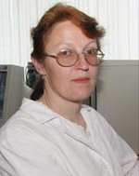 Senior Lecturer Naumjuk Elena Petrovna
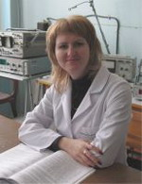 Senior Lecturer Zavadskaya Viktorya Mikchailovna
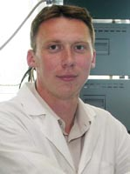 Senior Lecturer Kapytski Andrei Vitalievich
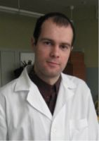 Lecturer Kaliuta Evgeniy Aleksandrovich
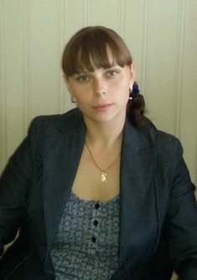 Lecturer Sakovich Tatiana Nokolaevna

