The Criteria were discussed and
accepted at meetings of the
Department of Microbiology,
Virology and Immunology named
after S.I. Gelberg
on the 19th and 26th January 2015
(Protocols N 7 and N 8)

Criteria

for a 10-grade scale evaluation of the knowledge on Microbiology shown by international students at the Department of Microbiology, Virology and Immunology named after S.I. Gelberg of
Grodno State Medical University

1. Criteria for the evaluation of the knowledge shown by the students at current lessons
Every student gets a mark at every lesson. Students have only one chance to pass the test
of their knowledge of the current lesson.
For the estimation of the knowledge shown by the students during the current lesson the algorithm shown bellow is applied (fig. 1).

The final mark estimation

Fig.1.The algorithm used for the estimation of the knowledge shown by
students during the current lessons.

Computer-based work is a basic part of the lesson revealing the knowledge of theoretical material. This work includes the next categories of questions and tasks which a student has to perform:
- to choose one right answer from the proposed variants;
- to choose several right answers from the proposed variants;
- to choose the variants according to their conformity;
- to choose the variants corresponding to their accordance to the group;
- to choose the variants corresponding to their right sequence;
- to type the answers using the key-board of the computer.

The student has to give answers to 15 questions on the theme of the current lesson in 15 minutes. The complexity of the questions differs, so the input of every answer into the final mark is different. Besides that, the answers on the questions from the categories indicated in the list (see above) as N2 to N5 as well as some questions from the category N 6 are evaluated softly. The proportion of correct and incorrect answers accounting soft evaluation of the answers from the categories from N2 to N5 is calculated by computer program which gives the mark got by student after fulfilling the computer work. The mark is dependent on the amount of right answers and can vary from 1 to 8 (fig. 2).

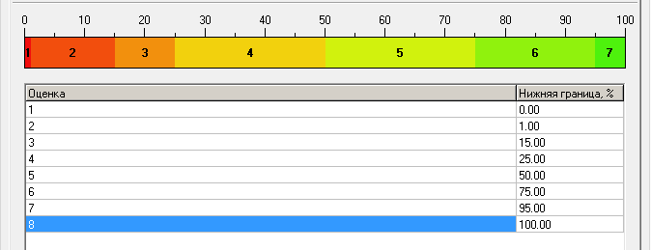
mark
the lowest level of the result in %
Fig. 2. The criteria of the estimation of results of the computer-based work at current lesson.

Computer-based work is created with use of the basic information of the lecture material on the current theme and presented in a brief form called the short summarized lecture material. Every student is supplied with the electronic version of this information.
At the theoretical part of every lesson (at the seminar) every student is asked to answer one of the self-assessment questions on the current theme orally to demonstrate knowledge of additional material (which was not included into the short summarized lecture material) such as the information given by a lecturer during the lecture or additional material that student learned from the textbooks, Internet or other sources. If the answer given by a student is correct and presents an additional knowledge of the question, the basic mark of the student will be increased by 1 grade. If a student gives wrong answer the basic mark will be not decreased.
During oral seminar and discussion on the theme of the current lesson a lecturer asks the students two special thinking questions or situational tasks to give every student an ability to confirm good knowledge and understanding of the additional material. If the answer on the first special theoretical question is not given or is not right student does not get the chance to answer the second question and will not get any additional grades, but the basic mark remains the same. For every right answer the mark of a student will be increased by 1 grade. To involve all students from the group into active work and discussion at the lesson in the case of students who failed to answer the additional questions a lecturer asks other students from the group to answer these questions. The student who gives the right answer will get additionally 1 grade to the basic mark for the lesson for every one that is correct. If the answers given are not correct the student does not get any additional grades but the basic mark remains the same.
During the practical part of the lesson the summarized mark of a student correspondently the knowledge and mastering the practical skills can be changed.
If a student shows little knowledge of the practical part of the lesson and does not master practical skills the summarized mark for the lesson will be decreased by 1 grade.
If student shows excellent knowledge and masters practical skills the mark will be increased by 1 grade.
The final mark obtained by the student from the current lesson is calculated by summarizing the computer-based work, additional grades (if there were any) obtained by the student during oral seminar. 1 grade is added to the total mark for good results of self-dependent laboratory work or one grade is to be taken off from the total mark if the results of self-dependent laboratory work were unsatisfactory.

2. Criteria of the evaluation of the knowledge shown by students at the Concluding lesson

At the Concluding lesson the basic mark is calculated as average value using the formula:

0,4 × A + 0,4 × C+ 0,2 × S= the basic mark
where:
A – the average mark got by student during study of the corresponding Section of Microbiology,
C – the mark got by student for computer-based work,
S – the mark got by student for mastering practical skills.

The questions of all lessons of the corresponding Section are included into computer-based work. The number of questions and the limit of time are the same as at the usual lessons but the criteria of the mark evaluation are different (see the fig.3).

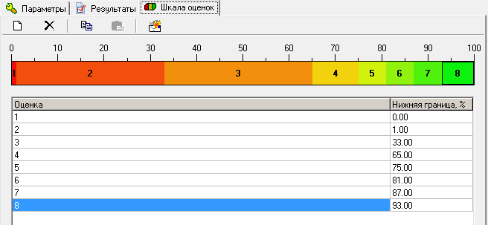
the lowest level of the result in %
mark
Fig. 3.The approaches to the estimation of the results of computer-based work
at the Concluding lesson.

At the concluding lesson a student will get one theoretical question and will be asked to answer orally to demonstrate knowledge of additional material (that was not included in the short summarized lecture material) but was given by a lecturer at the lecture or additional material that the student learned from the textbooks, Internet or other sources. If the answer given by a student is correct and shows additional knowledge on the question, the basic mark of the student will be increased by 1 grade. If a student gives the wrong answer the basic mark will be not decreased and the lecturer will ask student to answer the next two special theoretical questions.
If the answers on the first special theoretical question is not given or is not right student does not get the chance to answer the second question and will not get any additional grades, but the basic mark remains the same. For every right answer the mark of a student will be increased by 1 grade.
So during an oral seminar at the lesson (both current and concluding ones) a lecturer asks students theoretical questions to give the students the ability to confirm their knowledge and understanding the additional material. For every right answer the mark of a student will be increased by 1 grade. If the answers on the questions are not given or not right the students do not get any additional grades but the basic mark remains the same.
If the student given an additional question failed to answer, this question could be put to other students from the group and the student who gives the right answer will get an additional 1 grade to the basic mark for the lesson for every right answer. If the given answers are not right the student does not get any additional grades but the basic mark remains the same.
To calculate the final mark obtained by a student at the Concluding lesson the additional grades got by student (if the student has got any) will be added to the basic mark that was calculated according to the formula: 0,4 × A + 0,4 × C+ 0,2 × S.

3. Criteria of the evaluation of the knowledge and mastering the practical skills
shown by students at the Concluding lesson

Practical skills which students have to master at the practical lessons on the corresponding Section of Microbiology are estimated at the Concluding lesson. The skills are classified into eight groups: six groups of the skills are evaluated by computer as a result of computer-based work. The skills belonging to the other two groups are evaluated by a lecturer (see table 1).
Table1.
The groups of practical skills which students have to master at the practical lessons on the Sections of Microbiology(Section N1 – General Microbiology, Section N2 – Immunology and Section
N3 – Medical Bacteriology) and to perform at the corresponding Concluding lesson
 | The name of the skill | The number of the  Concluding lesson |  |  | The way of estimation
 |  | N1 | N2 | N3
1 | The algorithms of staining techniques | + |  | + | Computer-based work
2 | Making a smear, seeding of the material containing bacteria and other standard bacteriological techniques | + |  | + | A lecturer
3 | Immersion microscopy technique | + |  | + | A lecturer
4 | The algorithms of setting up serological reactions |  | + | + | Computer-based work
5 | The estimation of the results of serological reactions (reading of the results of the tests) |  | + | + | Computer-based work
6 | Identification of microorganisms in the smears | + |  | + | Computer-based work
7 | Evaluation of the immunogram |  | + | + | Computer-based work
8 | Visual evaluation of the growth characteristics of microorganisms and of their features | + |  | + | Computer-based work

Table 2.
The criteria of evaluation of the practical skills including making smear, seeding of the material
containing bacteria and other standard bacteriological techniques performed by a student
The evaluation of the performed work | The mark
Excellent work | 10
Good work but done with some inaccuracy | 8
Quite good work but done with insignificant mistake | 6
Work done with significant mistake | 3
Work has not been done | 1

Table 3.
The criteria of evaluation of immersion microscopy technique performed by a student
Time taken for the performance of the technique | The mark
≤ 15 seconds | 10
16 – 30 seconds | 8
31 – 45 seconds | 6
46 – 60 seconds | 3
> 60 seconds | 1

At the stage of the evaluation of the practical skills mastered by students every student has to carry out the computer-based work and to demonstrate the ability to perform to the work carried out manually: such as making a smear, seeding of the material containing bacteria and other standard bacteriological techniques, as well as immersion microscopy technique.
When knowledge of practical skills which students have to master at the practical lessons is evaluated at the Concluding lesson by computer-based work every student has to answer 10 questions during 10 minutes. The approaches to estimation of knowledge of practical skills are present in the figure 4.

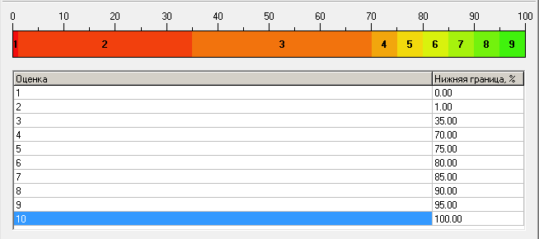
mark
the lowest level of the result in %
Fig. 4.The approaches to the estimation of the knowledge of practical skills
performed by computer-based work at the Concluding lesson.

The mark obtained by a student for knowledge of practical skills at the Concluding lesson is calculated according to the formula: 0,5 × C + 0,3 × М + 0,2 × S

where:
C – the mark got by student for the knowledge of practical skills during computer-based work,
M – the mark got by student for mastering microscopy techniques,
S – the mark got by student for mastering standard bacteriological techniques.

Taking into account that complete knowledge and mastering all practical skills that are covered by the Teaching Program are controlled at the Concluding lesson on the Section “Medical Bacteriology” the mark which every student will get at this Concluding lesson will be accepted as the final examination mark gained by the student for mastering practical skills (no any additional examination on practical skills will be performed at the examination).

4. Criteria of the evaluation of the knowledge shown by students during Examination
At the examination every student has to pass completely demonstrating knowledge on all Sections of the subject: General Microbiology, Immunology, Medical Bacteriology and Virology. So the questions from all lessons of the whole course will be included into computer-based work. The number of questions and the limit of time will be the same as at the usual lessons but the criteria of the mark evaluation will be different (see the fig.5).

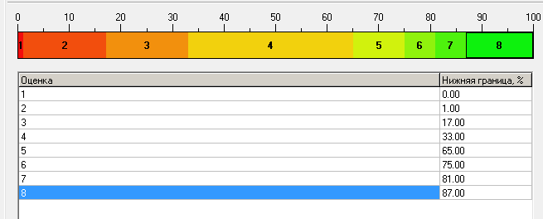
the lowest level of the result in %
mark
Fig. 5. The approaches to the estimation of the results of computer-based work
performed at the Examination.

After completing the computer-based work every student gets an Examination paper (examination card). The Examination paper will include four questions on every Section of the subject. Every student will get a chance to demonstrate knowledge of additional material on each question of the Examination paper. Additional material means the information given by a lecturer during the lecture or additional material that student learned from the textbooks, Internet or other sources – this information was not included into the short summarized lecture material on the theme. If the answer given by a student is correct and presents an additional knowledge of the question, the mark obtained by the student for the computer-based work will be increased by 1 grade for every right answer. So students can get a maximum of four grades to increase their mark for the knowledge of theoretical material. If a student gives the wrong answers the mark will be not decreased.
As a result of passing computer-based work and oral answers on the Examination paper every student gets the basic Examination mark. The basic Examination mark is calculated as average value using the formula:
0,4 × A + 0,5 × E+ 0,1 × S= the basic Examination mark

where:
A – Average mark obtained by student during study of the whole course (all four Sections) of Microbiology. This mark is calculated as average from the marks got at the Concluding lessons on General Microbiology, Immunology, Medical Bacteriology and the average mark on Virology (calculated as average of all marks got at the current lessons on the Section).
E – the Examination mark obtained by student for the knowledge of theoretical material on four Sections of Microbiology: it includes computer-based work and additional knowledge on the questions of examination paper,
S – the Examination mark obtained by student for mastering practical skills (see paragraph 3).

At the concluding part of the Examination a lecturer asks student to give answers on four special theoretical questions/or situational tasks (one question per every Section of Microbiology). For every right answer basic Examination mark of the student will be increased by 1 grade. If the answers on the questions are not given or are not right the student does not get any additional grades but the basic Examination mark remains the same.
So the final Examination mark is calculated using the formula:
final Examination mark = basic Examination mark + Q,

where:
Q – the number of additional grades obtained by the student for answers on special theoretical questions/or situational tasks at the concluding part of the Examination.

5. Evaluation of the knowledge of students in case of using the cribs during Examination
Using cribs (in any form: including mobile phones or other electronic equipment) by students is strictly prohibited at any stage of the Examination.
If a student is found to be talking to another while they are preparing their answers or answering at any stage of Examination this is evaluated as using cribs.
If student uses cribs during computer-based work the work must be stopped and the student gets the minimal mark – 1 grade (using cribs is evaluated as a refusal of the student to answer). Such a student has a right to participate in the next stages of the Examination but computer-based marks on all Sections of Microbiology will be the minimal: 1 grade.
In the case of using cribs during any other stages of the examination the Examination will be stopped without the student getting any additional grades for answers on the corresponding question of the Examination paper.

Head of the Department of Microbiology, Virology
and Immunology named after S.I. Gelberg,
senior lecturer A.I. Zmakin

Responsible for the academic process
at the Department,
senior lecturer S.A. Astrautsova

