Wenqian Wang, Ph.D. M.D.
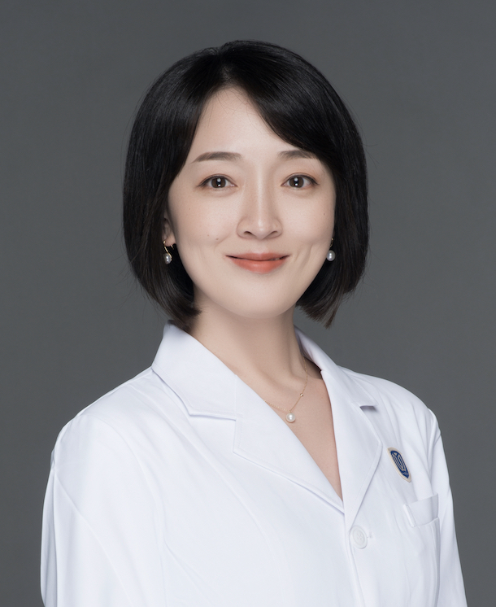
Address:
Department of Plastic Surgery, The Second Affiliated
Hospital and Yuying Children’s Hospital of Wenzhou Medical
University, Wenzhou 325027, Zhejiang Province, China.
Telephone: +86-577-88002234
Fax: +86-577-88002234
Email: wangwenqian@wmu.edu.cn

Biography:
Dr. Wenqian Wang got Ph.D. in 2017 in Tokyo Medical and Dental University (Japan) and then was brought in talents in Wenzhou Medical University. Her research group was funded by National Natural Science Foundation of China. Her research goals are to propose novel treatment strategies for breast cancer. For a better understanding of the characteristics of breast cancer, multi-directional approaches are indispensable, and technological innovation with splendid research concepts are required.
Selected Publications:
1. Hua C, Chen J, Li S, Zhou J, Fu J, Sun W*, Wang W*. KDM6 demethylases and their roles in human cancer. Front Oncol. 2021,11:779918. (IF=6.244)
2. Wang W, Yue C, Gao S, Li S, Zhou J, Chen J, Fu J, Sun W, Hua C. Promising roles of exosomal microRNAs in systemic lupus erythematosus. Front Immuno. 2021,12:757096. (IF=7.561)

3. Gao S, Yi Y, Xia G, Yu C, Ye C, Tu F, Shen L, Wang W*, and Hua C*. The characteristics and pivotal roles of triggering receptor expressed on myeloid cells-1 in autoimmune diseases. Autoimmunity Reviews. 2019, 18:25-35. (IF=9.754)

4. Sun W, Yi Y, Xia G, Zhao Y, Yu Y, Li L, Hua C, He B, Yang B,Yu C, Ye C, Tu F, Chen C, Xu X, Zheng Z, Wang W*, and Shen X. Nrf2/miR-129-3p/mTOR Axis Controls a miRNA Regulatory Network Involved in HDACi-induced Autophagy. Molecular Therapy.2019, 10:1016. (IF=11.454)
5. Wang W, Tabu K, Hagiya Y, Sugiyama Y, Kokubu Y, Murota Y, Ogura S and Taga T. Enhancement of 5-aminolevulinic acid-based fluorescence detection of side population-defined glioma stem cells by iron chelation. Sci Rep, 2017, 7: 42070.

